PRODUCT DESCRIPTION: TEMPERATURE PROBE
1. PURPOSE
To set the required specification for Temperature Probe producing by Saudi Mais company to ensure good quality products delivered to the customers.
2. SCOPE
This document is applicable for all variants of Temperature Probe delivered non-sterile by Saudi Mais Co. for Medical Products.
3. QUALITY FEATURES
- Good quality, clear and good appearance.
- Free from any defects, sensor and the pins strong attachment and without rust particle.
- Flexible, clear and kink resistant cable.
- Skin temperature probes provide a non-invasive method.
- It’s help monitor the body temperature.
- Probe designed for single patient use only.
- Clear & proper printed label.
4. Product Code (Temperature Probe)
Product Code | Descriptions | Sterility
TP-NDI | Temperature Probe Neonate Drager Incubator. | Non-Sterile
TP-NDI | Temperature probe-neonate Drager incubator to maintain NTE in the Drager incubator, and control Babies temperature the Drager incubator temperature probe must be used, or the bed will fail to do its job has declaration of compatibility certificate with Drager devices, DEHP free location: | Non-Sterile
TP-PDI | Temperature Probe Pediatric Drager Incubator. | Non-Sterile
TP-ADI | Temperature Probe Adult Drager Incubator. | Non-Sterile
TP-NGI | Temperature Probe Neonate Giraffe Incubator. | Non-Sterile
TP-SA | Temperature Probe for Adult Skin Type, Disposable. | Non-Sterile
TP-RP | Temperature Probe for Pediatric Rectal Type, Disposable. | Non-Sterile
TP-RP01 | Probe temperature rectal, pediatric, length not less than 1.5M disposable, (should be compatible with Draeger machine or equivalent). | Non-Sterile
TP-RP02 | Probe temperature rectal, pediatric, length not less than 1.6M disposable, (should be compatible with Draeger machine or equivalent). | Non-Sterile
TP-RP03 | Probe Temperature rectal, pediatric, length not less than 3M disposable, (should be compatible with Draeger machine or equivalent) | Non-Sterile
TP-RA | Temperature Probe for Adult Rectal Type, Disposable. | Non-Sterile
TP-RA01 | Probe temperature rectal, adult, length not less than 1.6M disposable, (should be compatible with Draeger machine or equivalent) | Non-Sterile
TP-RA02 | Probe temperature rectal, adult, length not less than 3M disposable, (should be compatible with Draeger machine or equivalent) | Non-Sterile
TP-AT | Probe temperature Tympanic adult. | Non-Sterile
TP-PT | Probe temperature Tympanic pediatric. | Non-Sterile
TP-SP | Temperature Probe for Pediatric Skin Type, Disposable. | Non-Sterile
TP-SA01 | Temperature Sensor Skin 400 Series latex free. | Non-Sterile
TP-ULP3 | Probe ultrasonic lithotripsy with oscillating tip and suction channel, 3 mm | Non-Sterile
TP-RN101 | Probe core temperature "rectal", complete with neonatal, total body cooling, tecotherm or equivalent, neonate. | Non-Sterile
TP-RN102 | Probe temperature for esophageal or rectal for intravascular temperature management machine. | Non-Sterile
TP-SN102 | Probe for temperature skin, compatible with neonatal total body cooling techotherm neo, or equivalent disposable. | Non-Sterile
TP-WALN | Probe oral temperature for thermometer, electronic, compatible with welch allyn. | Non-Sterile
TP-15HS | Temperature probe heat sensor 1.5m compatible with MR850 or equivalent. | Non-Sterile
5. Temperature Probe Drawing and Dimensions
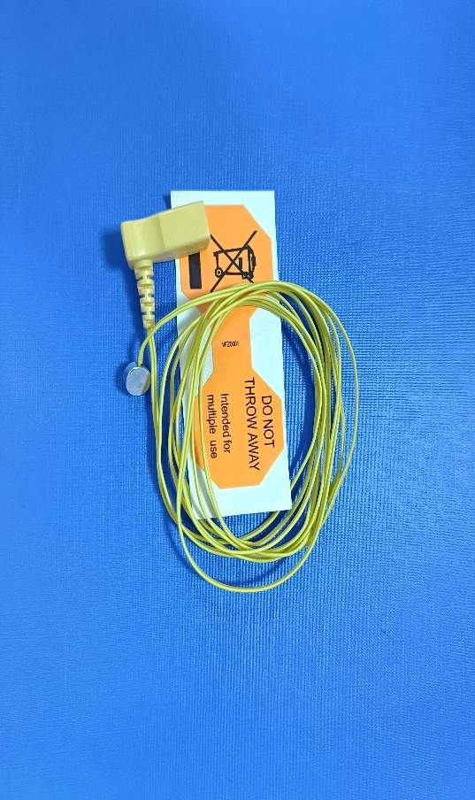
6. Temperature Probe Raw Material Specification
Sr | Part Description | Material
1. | Sensor | Stainless steel
2. | Cable | Copper wire over PVC jacket with yellow colorant
3. | Connector | PP with yellow colorant
4. | Pin | Copper
5. | Label | Adhesive Paper material
7. PHYSICAL PROPERTIES
7.1 Visual Appearance
When examined by normal vision the entire surface of each part should be clean and free from irregularities defects.
7.2 Sensor
The sensor should be good quality, clear and good appearance. Free from any irregularities should be smooth surface, no sharp edges, without rust particle, good connection with the cable and accurate reading.

7.3 Cable
Clear and smooth visual surface of the cable. The cable should be free from any irregularities no black spot, no cuts, flexible and kink resistant cable, good connection with connector and the sensor, accurate reading. (cable length- 150 cm ±1 cm).
7.4 Connector
Good quality, clear and good appearance. The connector should be free from any irregularities defect no black spot, no short-short, smooth surface no sharp edges and no flashing, end soft round cutting. The connector should be strong attachment with the pins and cable, accurate reading.
7.5 Pin
Good quality, good appearance and strong attachment. The pins must be straight, smooth surface without rust particle, no bend and no damage. Good connection with the monitor and accurate reading.
7.6 Label
Label should be accurate in dimension clear and proper printed information, straight cutting edges.
8. PACKAGING & LABELLING
Each Temperature Probe first put on zip lock bag then packed by packaging paper and film pouch.
- The single piece label contains the following information_
  - The item name, size and code / reference.
  - For single use, read instruction, & storage temperature.
  - Lot number, Reference number, production date and expiry date.
  - Medical device symbols.
  - Read instructions before use.
  - Manufacturer name and address.
- The label on the shipping big carton bears at least the following information:
- Item name, size and code / reference.
- Lot number, production date, Expiry date.
- For single use, read instruction, store temperature.
- Manufacturer name and address.
- Authorized European Representative Name and address.
- Quantity per carton.
8.1 Packaging Specification
Sr. | Description | 34x16x12 cm |  | 51x35.5x36 cm
Sr. | Description | Pcs/Box | Small Box | Pcs/Carton
Sr. | Description | Qty | Qty | Qty
1. | Temperature Probe | 30 | 8 | 240
- And the cartons contain the fallowing symbol; keep side up – upside down prohibited_
  - Do not expose to direct sunlight, store at room temperature.
  - Handle with care.
  - Use no hooks.
  - Fragile.
  - Do not stock more than 8 cartons.
9. EXPIRY DATE
The expiry date is (3) years from its manufacture date.
10. DOCUMENT CHANGES HISTORY
Date | Revision | Changes History
18.02.2025 | 00 | 1st Issue

